Customer Support RAG System
Objective
The objective of this project is to build a Customer Support solution that can:
- Answer user questions based on internal company documents using Retrieval-Augmented Generation (RAG)
- Avoid hallucinations by suggesting support ticket creation when answers are not found
- Automatically create support tickets in an issue tracking system using function calling
- Be deployed as a web application on Hugging Face Spaces

2. Business Features Implementation
2.1 Web Chat Interface
The system provides a web-based chat interface built with Streamlit, where users can:
- Ask questions related to company documents
- Receive answers with document citations
- Create support tickets if an answer is not available
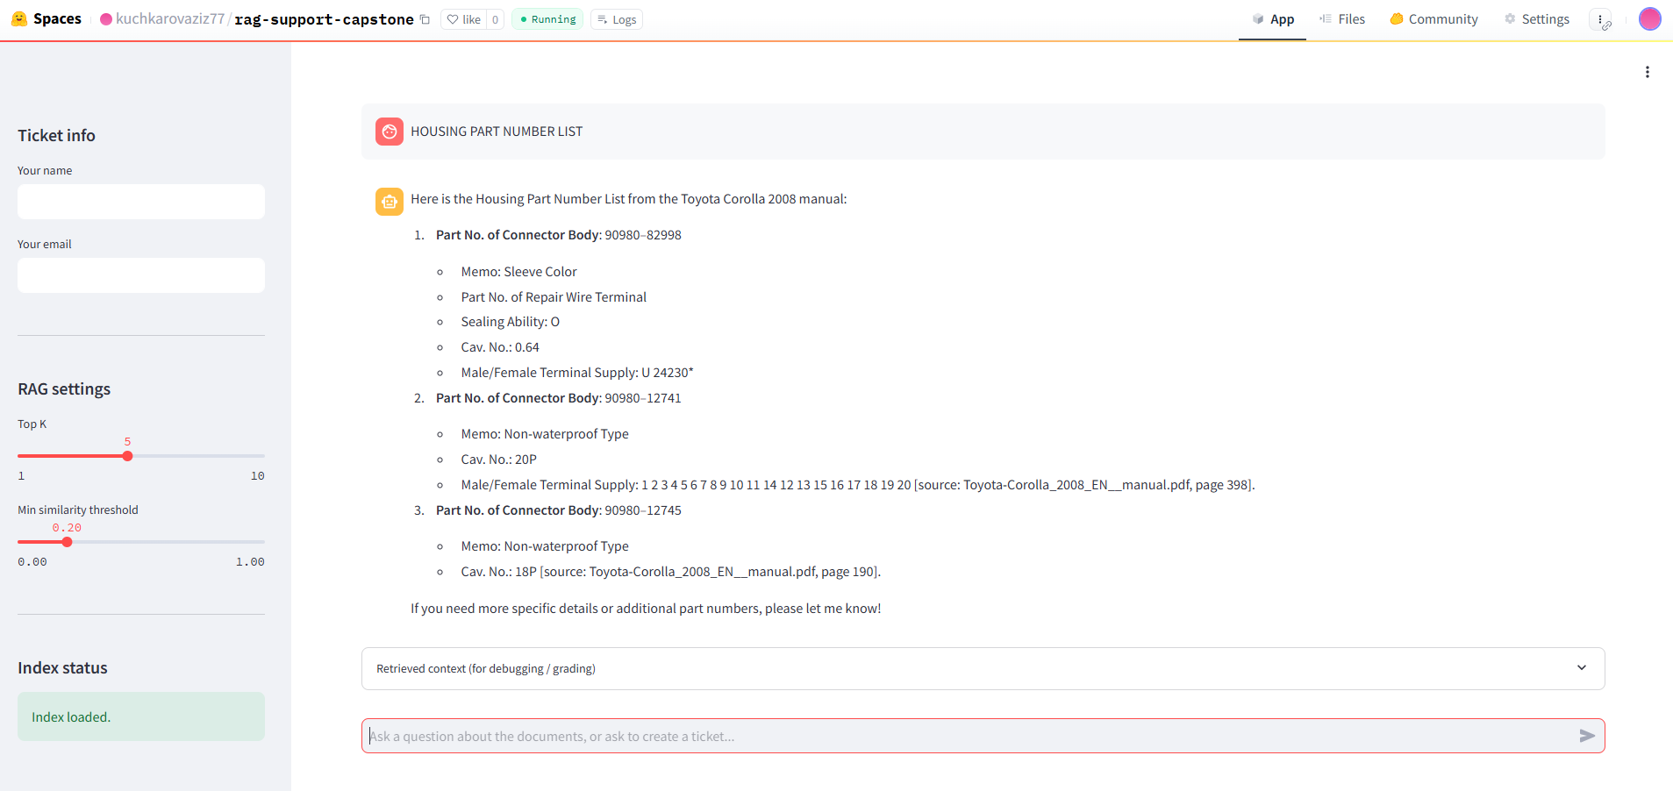

2.2 Answering Questions from Datasources
The system uses Retrieval-Augmented Generation (RAG):
- User questions are embedded and compared against document embeddings
- Relevant document chunks are retrieved from a vector database
- The AI model generates an answer based only on retrieved content
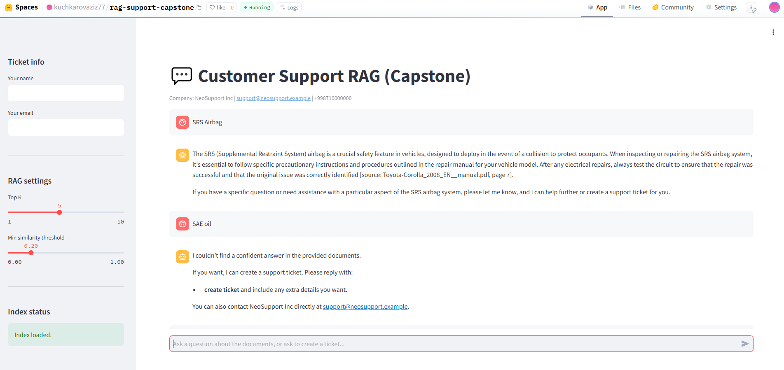

2.3 No-Answer Handling & Ticket Suggestion
If the system cannot find a confident answer:
- It does not hallucinate
- It suggests creating a support ticket
- This behavior is controlled by a similarity threshold
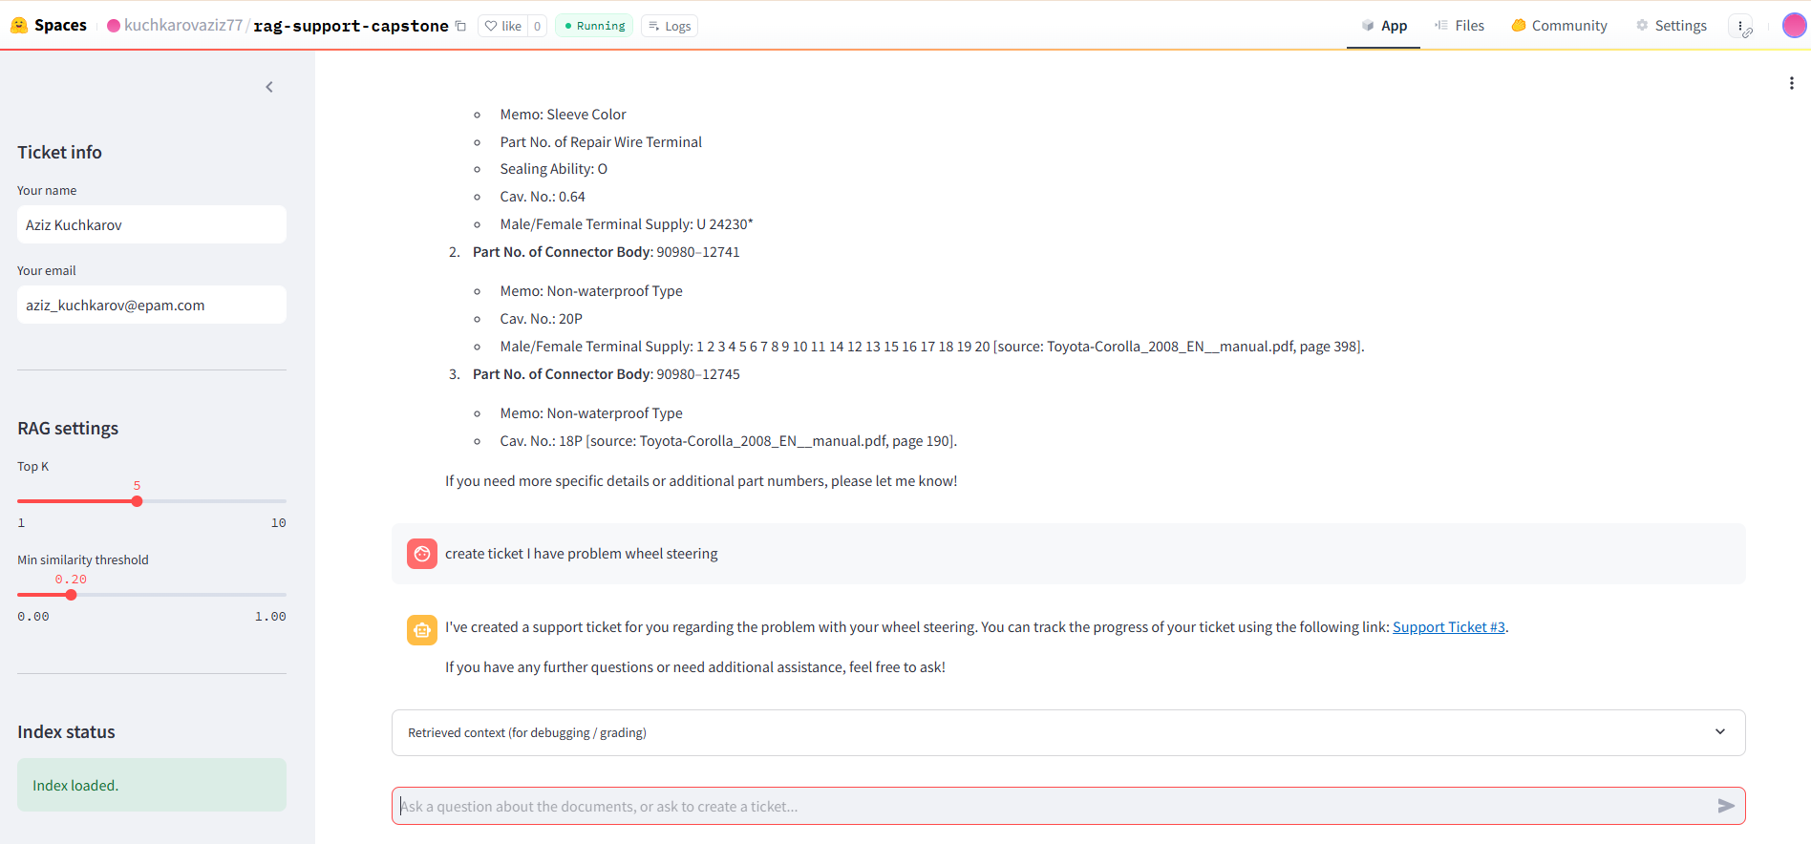

2.4 Support Ticket Creation (Function Calling)
Users can instruct the system to create a support ticket.
Each ticket contains:
- User name
- User email
- Summary (title)
- Detailed description
Tickets are automatically created as GitHub Issues using function calling.
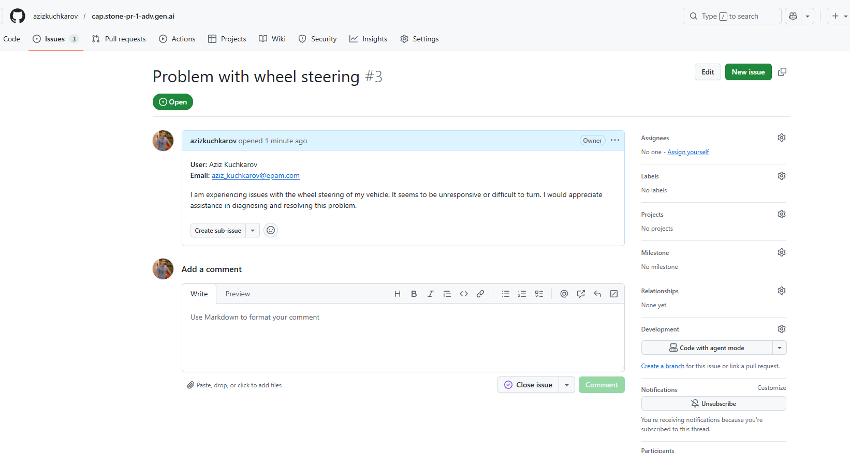

2.5 Issue Tracking System
- GitHub Issues is used as the issue tracking system
- Tickets are created programmatically using GitHub API
- Each ticket represents a real support request

2.6 Document Citation
When an answer is generated from documents, the system provides:
- Document file name
- Page number
Example:
Source: Toyota-Corolla_2008_EN__manual.pdf, page 312
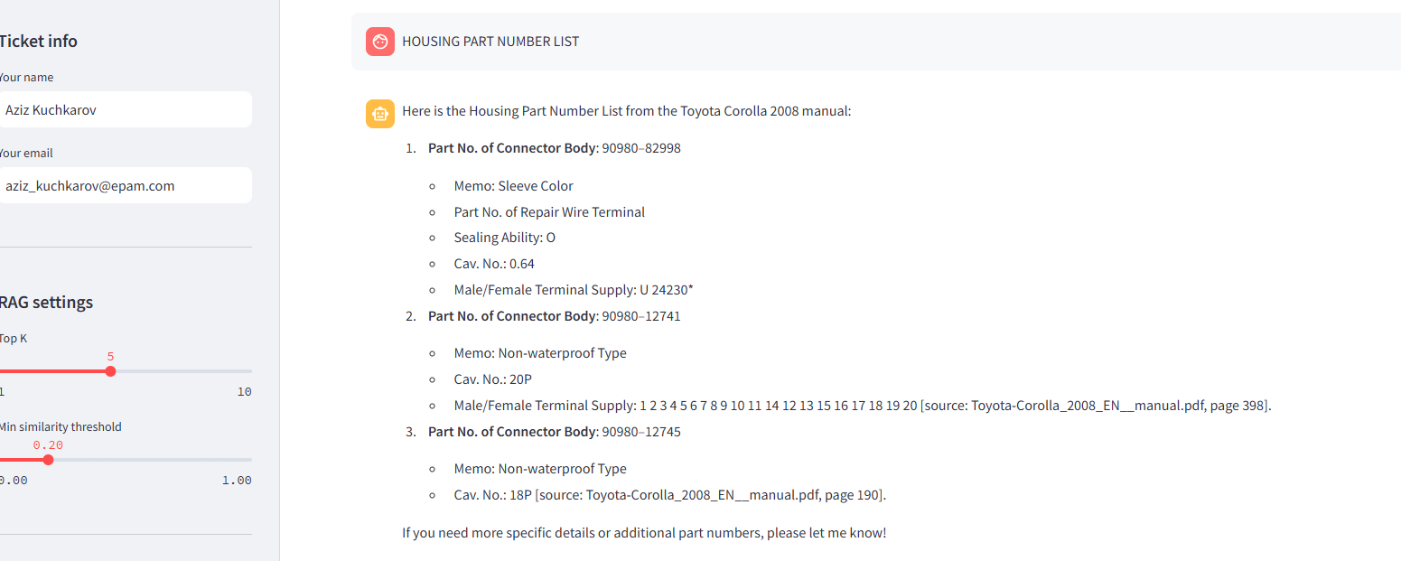

2.7 Conversation History
The system maintains conversation history:
- Previous messages are included in the context window
- Follow-up questions are answered correctly based on prior interaction

2.8 Company Awareness
The AI system is aware of company information:
- Company Name: NeoSupport Inc
- Support Email: support@neosupport.example
- Phone Number: +998 71 000 00 00
This information is displayed in the UI and used in responses.


3. Data Sources
The system uses three documents as data sources:
Document Name | Type | Description
Toyota-Corolla_2008_EN__manual.pdf | PDF | Vehicle manual (400+ pages)
Company-Policy-and-Procedure.pdf | PDF | Internal company policy
FAQ Document | Text | Support FAQ
Data Requirements Compliance
- At least 3 documents
- At least 2 PDF documents
- At least 1 PDF with more than 400 pages
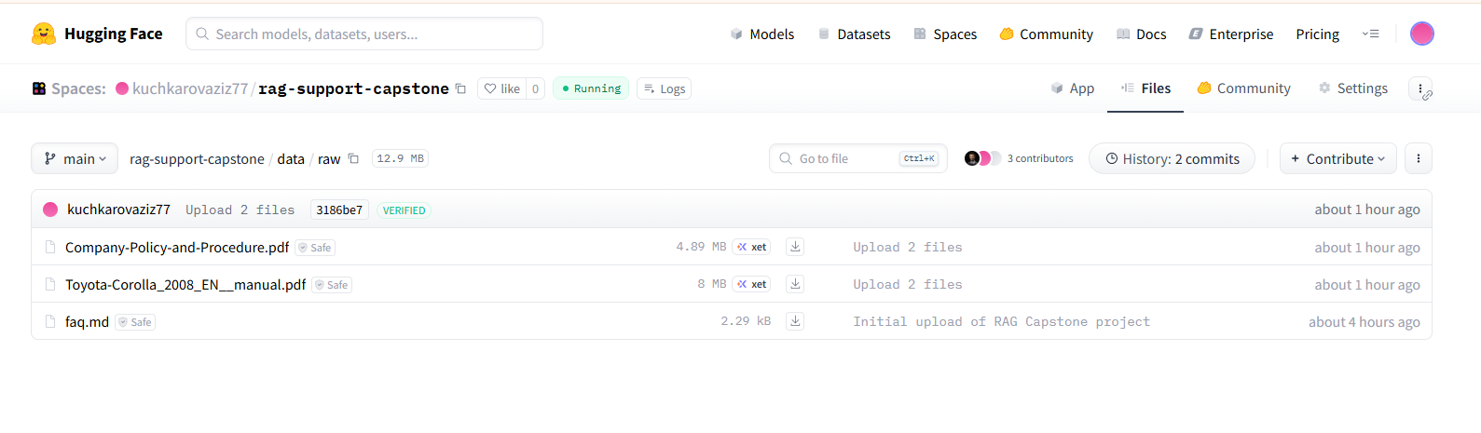

4. Technical Architecture
4.1 Programming Language
- Python 3.11
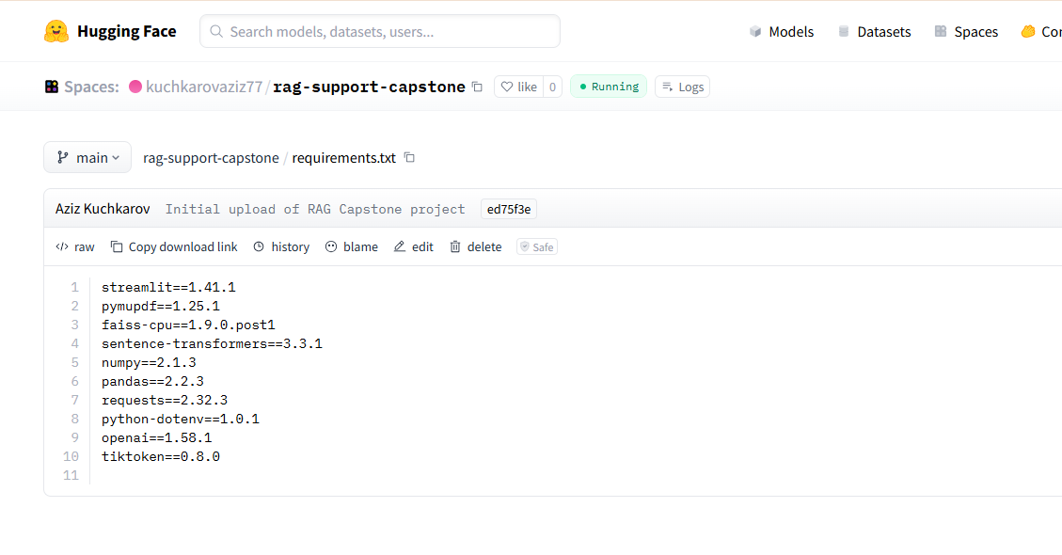

4.2 Vector Storage
- FAISS is used as the vector database
- Documents are embedded and stored locally
- Vector index files:
  - index.faiss
  - docstore.pkl
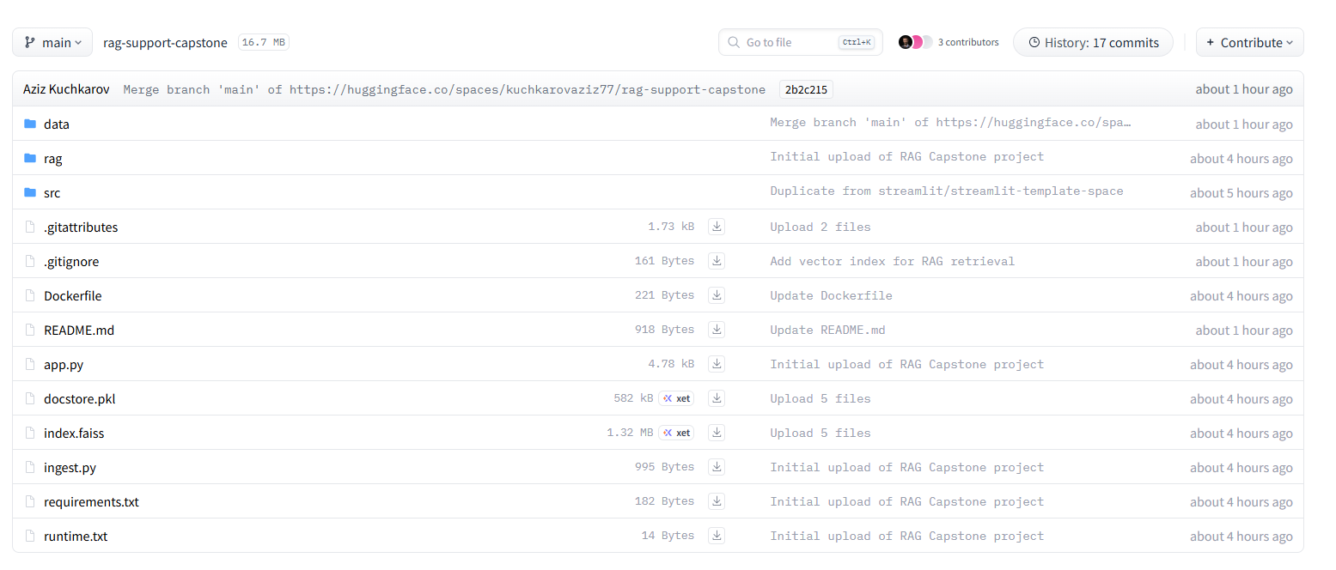

4.3 Function Calling
Function calling is implemented to:
- Create GitHub Issues as support tickets
- Pass structured parameters (name, email, summary, description)

4.4 Application Structure
app.py # Streamlit UI
rag/ # RAG logic (loaders, prompts, tools)
ingest.py # Document ingestion and indexing
requirements.txt # Dependencies
Dockerfile # Deployment configuration

5. User Interface
- Built using Streamlit
- Includes:
  - Chat window
  - Ticket information sidebar
  - RAG configuration controls
  - Index status indicator

6. Deployment
Hosting Platform
- Hugging Face Spaces
Deployment Method
- Docker-based deployment
- Publicly accessible URL
Example:
https://kuchkarovaziz77-rag-support-capstone.hf.space
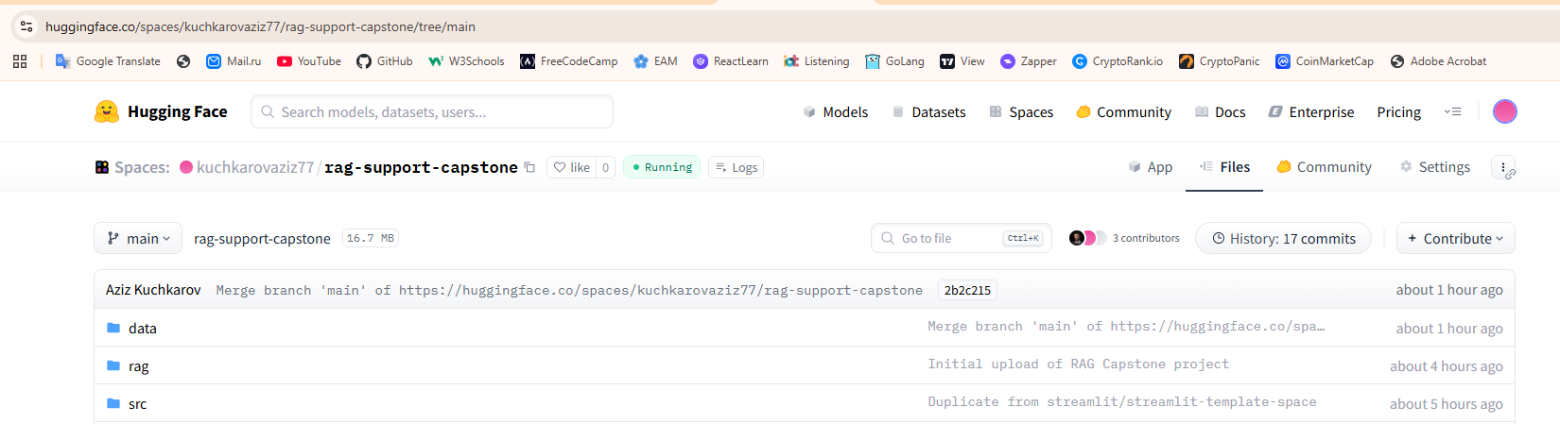

7. Demonstration Scenarios
Example Questions
- “What engine oil viscosity is recommended for Toyota Corolla 2008?”
- “What precautions should be taken when repairing the SRS airbag?”
- “What are employee responsibilities according to company policy?”
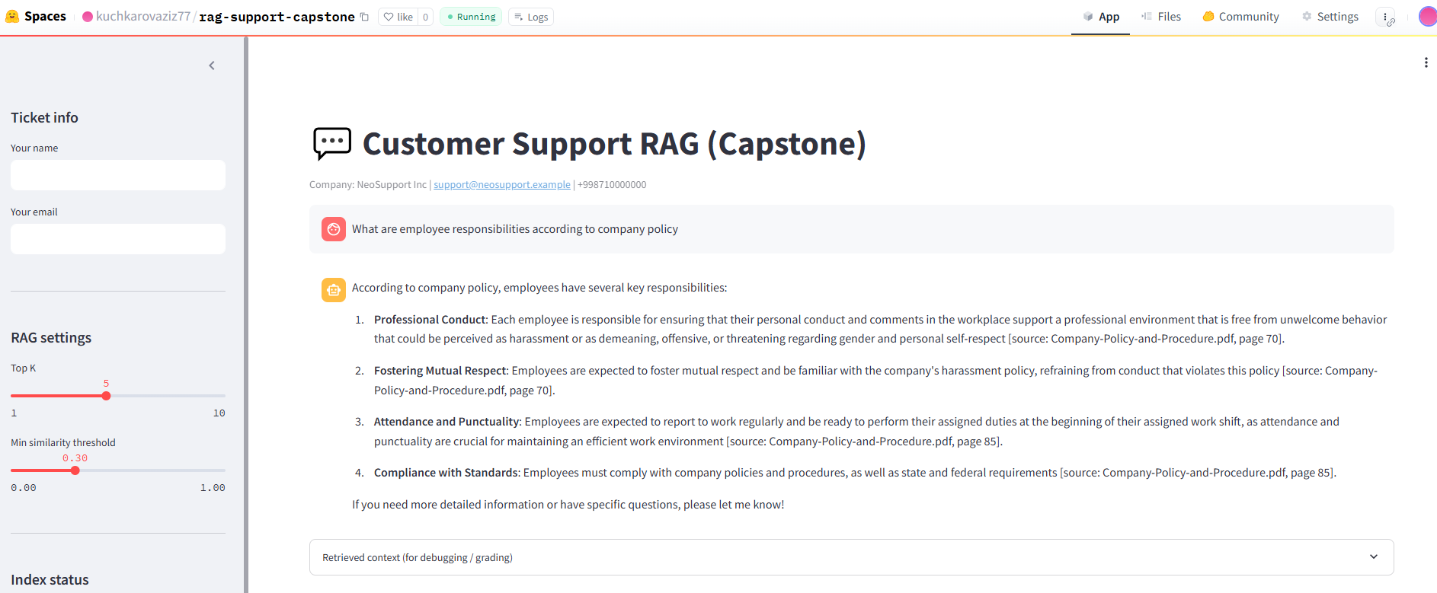
Ticket Escalation Scenario
- User asks an out-of-scope question
- System suggests ticket creation
- User confirms → GitHub Issue is created
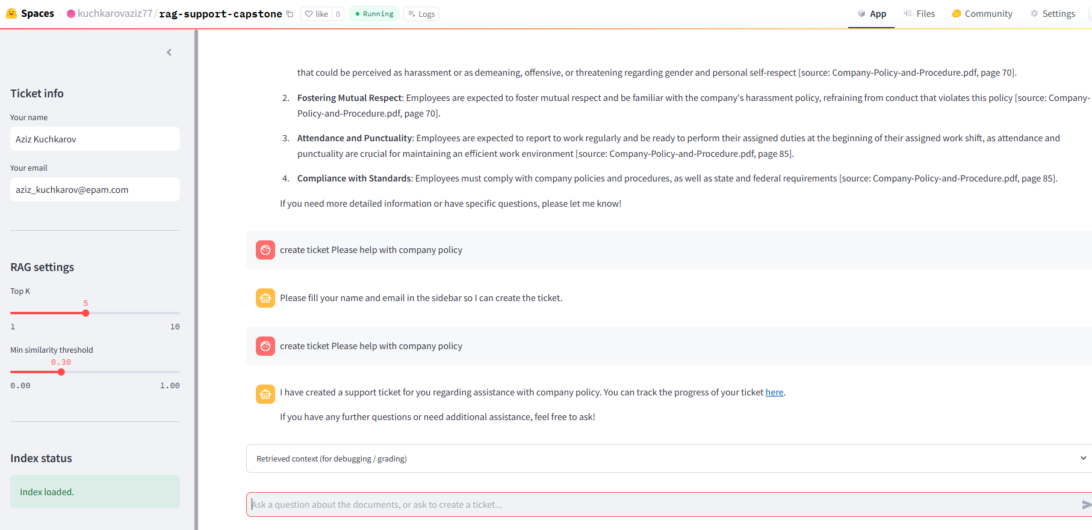
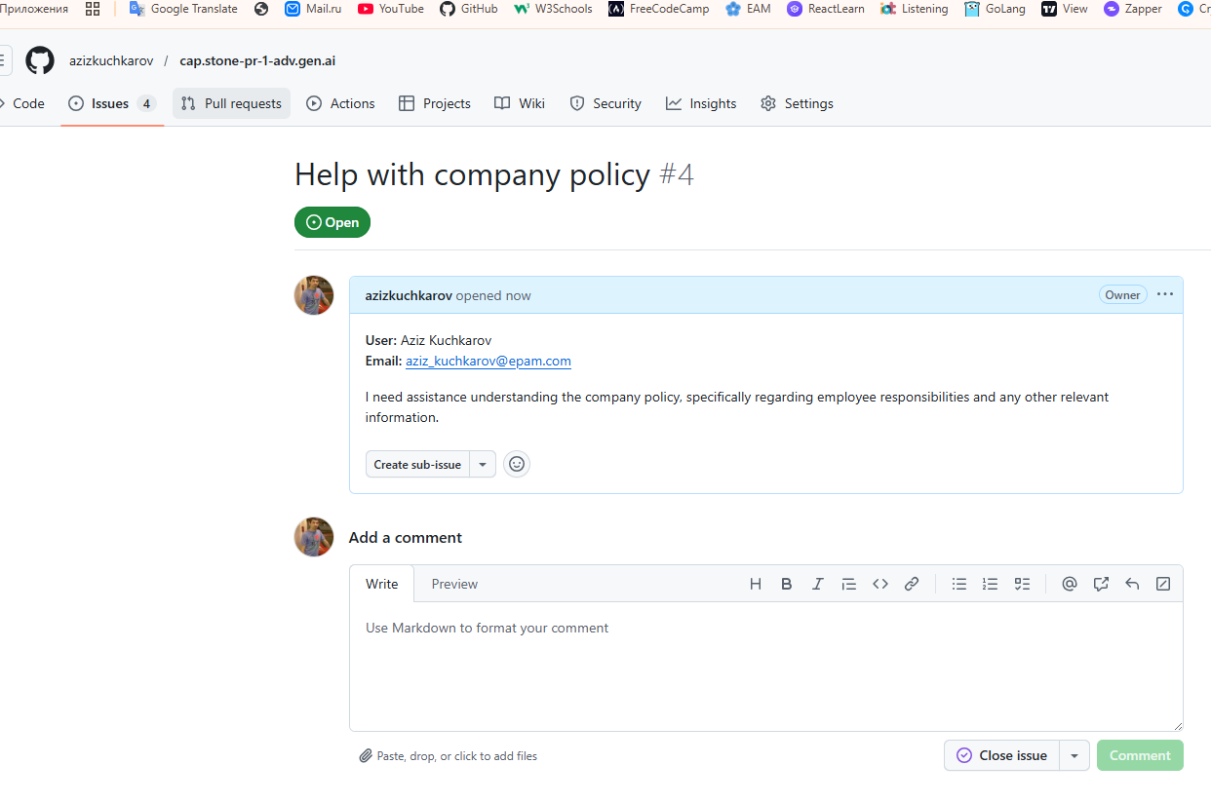

8. Conclusion
This project successfully demonstrates:
- A production-ready RAG-based customer support system
- Safe AI behavior with hallucination avoidance
- Real-world ticket escalation using function calling
- Deployment on Hugging Face Spaces
All business and technical requirements of the practical task have been fully implemented.

9. Links
- Hugging Face Space:
https://kuchkarovaziz77-rag-support-capstone.hf.space
- GitHub Repository: https://github.com/azizkuchkarov/cap.stone-pr-1-adv.gen.ai

